# ANNEX 8 - PEER REVIEW ROLLING FORECAST

**Reporting requirements**. DON Contracting Activities shall submit quarterly, by March 10, June 10, September 10, and December 10, a rolling forecast of acquisitions requiring peer reviews by

DASN(P) or DPC. Use the DON Peer Review Rolling Forecast spreadsheet format when

submitting reports. Submit reports via email to [RDAJ&As.fct@navy.mil](mailto:RDAJ&As.fct@navy.mil) with the subject:

“DFARS 201.170 –Peer Review Rolling Forecast.” The electronic version of this

template can be found at <https://www.secnav.navy.mil/rda/DASN-P/Pages/NMCARS.aspx>.

**DON Peer Review Rolling Forecast Spreadsheet**

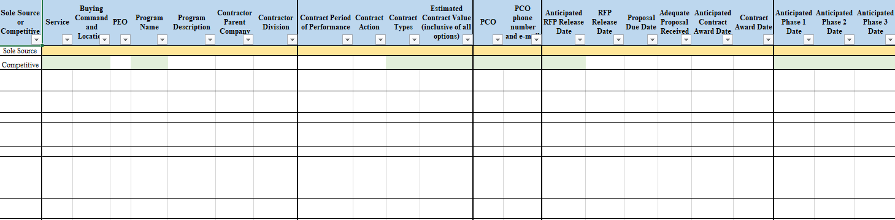

*-continued columns on spreadsheet*

